Distribution: limited | IFAP-2007/Bureau.XII/Inf.9  Paris, 8 March 2007  Original: English

UNITED NATIONS EDUCATIONAL,
SCIENTIFIC AND CULTURAL ORGANIZATION

Intergovernmental Council for the Information for All Programme

Twelfth Meeting of the Bureau

UNESCO House, Paris, Bonvin Building, Room XIII

2-4 April 2007, 9:30-12.30 and 14.30-17:30

IFAP National Committees

Item 5 d) of the provisional agenda

A. Background
- Recognizing the importance of IFAP National Committees, the Intergovernmental Council for the Information for All Programme, at its fourth session (March 2006), requested the Secretariat and the Bureau to develop plans, strategies and guidelines for IFAP National Committees in order to foster the creation of new IFAP National Committees, strengthen existing ones and reinforce the coordination among IFAP National Committees, the Bureau and the Council.
- The Bureau then agreed to focus the activities of the National Committees on three items at national level:
  - Effectively disseminating IFAP ideas and concepts;
  - Promoting international standards instruments and charters; and
  - Supporting the implementation of the World Summit on the Information Society (WSIS) outcomes.
- This document presents the actitivies undertaken by the Secretariat over the last six months, subsequent to the 11th meeting of the Bureau (September 2006), and provides an update on the current situation of the IFAP National Committees.

B. Creating new Committees
- Following the actions undertaken by the Secretariat in decentralizing funds from Regular Budget to field offices and establishing guidelines for its use in order to strengthen national and regional frameworks for IFAP, three countries (Ghana, Croatia and Nigeria) created their IFAP National Committees in 2006-2007.
- In June 2006, the Government of Croatia established a National Council for the Information Society which also serves as the Croatian National Committee for IFAP. The purpose of the Council is to provide a platform for international policy discussions and guidelines for development of the information society in Croatia. It is a government advisory body that provides council on proposals of strategic and policy documents, laws and projects related to information society, initiates and coordinates activities of various stakeholders. The Committee has 14 members who represent government, civil society, academic community and business sector. Administrative support for the Committee is provided by the Central State Administrative Office for e-Croatia. The Office is a central government body responsible for coordination, implementation and monitoring of the e-Croatia 2007 Programme, the national framework for information policy. The Head of the Office is the Chair of the Croatian National Committee for IFAP.
- In December 2006, the Government of Ghana established a National Committee for IFAP which comprises nine members, representatives of the following institutions:
- Public Records and Archives Adminitration Department (PRAAD)
- Ghana Museums and Monuments Board
- Council for Scientific and Industrial Research, Institute for Scientific and
- Technological Information (CSIR-INSTI)
- Department of Information Studies of the University of Ghana
- Ministry of Communications
- Ghana Library Board
- Copyright Office
- Ministry of Education, Science and Sports
- Ghana National Commission for UNESCO
The Ghana National Committee for IFAP will have the responsibility for overall management and monitoring of the Programme and its activities in Ghana. It reported to work in close collaboration with the Ghana National Commission for UNESCO, the UNESCO Cluster Office in Accra and the UNESCO Headquarters, meet at least twice a year and report annualy to the UNESCO Secretariat on its activities. The work plan foresees to develop a project and discuss how to make an impact on civil society, raise public awareness and feature articles in the media (April-May 2007), to discuss UNESCO’s Draft Programme and Budget for 2008-2009 (June-July 2007) and to visit one of IFAP’s projects in Ghana (August 2007). The Committee is chaired by Ms Christine Kisiedu, Associate professor at the Department of Information Studies of the University of Ghana.
- In March 2007, the Government of Nigeria also established a National Committee for IFAP which comprises representatives of the following institutions:
- National Library of Nigeria
- National Information Technology Development Agency (NITDA)
- African Regional Centre for Information Science (ARCIS)
- Nigerian National Commission for UNESCO
- Ministry of Information and Communications;
- National Archives;
- Senate Committee on Information
- House Committee on Information
- National Communication Commission
- GLOBACOM, a telecom operator
- Nigerian Library Association
The Nigerian Committee reported to focus on advocacy, capacity-building and project implementation to achieve the IFAP objectives, and to play the pivotal role in promoting the work of IFAP in Nigeria. It will meet every month.
- Since 2006, the Secretariat of the Russian IFAP Committee has been transferred to the Information Society Development Foundation, a non-commercial organization to which the Government of the Russian Federation has granted the right to perform this function and participate in the work of the Russian IFAP Committee. While the former Russian contact, Eugene Altovsky, is still actively involved in IFAP activities, shares regularly information with the Secretariat and maintains the Russian IFAP website at www.ifap.ru, the Russian National Commission for UNESCO informed the Secretariat of the newly established web site for IFAP at www.ifapcom.ru.
- The Korean National Commission for UNESCO is considering the establishment of a new IFAP Committee and convened a preparatory meeting with institutions in charge of international cooperation in March 2007. As one of the main outcomes of the discussion, participants expressed their wish to obtain more information on the current activities undertaken by other National Committees in order to activate their own. They recommended, along with the guidelines, the establishement of a platform to share good practices or examples of activities of the existing Committees.
- As for the content of the “good practices”, common questions raised by national focal points when creating a new Committee include the following:
- How do National Committees function financially? Where do they get financial contributions?
- How do National Committees promote IFAP values in the field? How do they translate the broad objectives of the Programme into concrete implementable activities at national level?

C. Enhancing the network of existing National Committees
- In supporting the establishment and growth of IFAP National Committees, the Secretariat provided the existing IFAP Committees with online communication tools.
- A mailing list for the 28 National Committees with verifiable email addresses was established (ifap-natcom@communities.unesco.org). This mailing list is frequently used to send announcements and share new publications.
- The National Committees were provided with access to the IFAP online collaborative space (http://sharepoint.unesco-ci.org/sites/ifap) and invited to update their profiles. The Russian Committee actively uses the space on regular basis to post announcements on IFAP related conferences and events in Russia.
- The following items were added to the online community:
- A list of profiles of IFAP National Committees with their up to date contacts and photos; and
- A discussion forum with common questions raised when creating new IFAP National Committees.
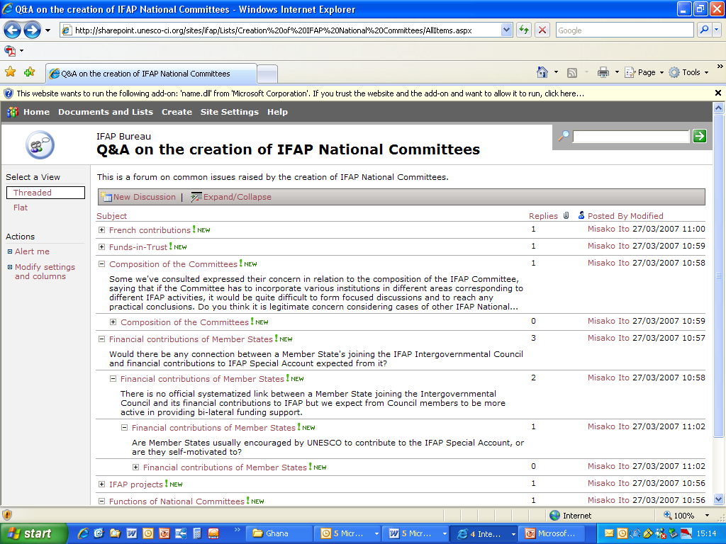

View of the Discussion forum on sharepoint

D. Current status of the IFAP National Committees
The detailed list of the IFAP National Committees with their current status is presented in Annex 1.

 | Number of countries | Regional distribution | Institutional framework
National Committee established with updated contacts | 25 | Africa: 4  Arab States: 3  Asia and the Pacific: 6  Europe and North America: 9  Latin America and the Caribbean: 3 | Under UNESCO National Commissions: 10  Within a governmental body: 9  Under the leadership of a technical, scientific or educational institution: 6
National Committee being established | 3 | Asia and the Pacific: 1  Europe and North America: 2

E. Recommendations
The IFAP Bureau is invited to endorse the following actions:
    - Define a strategy to promote IFAP values in the field and to translate the broad objectives of the Programme into concrete implementable activities at national level;
    - Actively encourage existing IFAP National Committees to share information on their current activities with other Member States that wish to launch or activate their own Committee; and
    - Establish a platform (online or offline) to share good practices or examples of activities undertaken by the existing National Committees to contribute to achieving IFAP goals at the national level.

Annex 1 – List of National Committees

ID | Country | Contact | Organization | E-mail Address | Current status
1 | Argentina | unknown
2 | Austria | Dietrich Schüller | Phonogrammarchiv Autrian Academy of Sciences | dietrich.schueller@oeaw.ac.at
3 | Belgium | unknown
4 | Brazil | unknown
5 | Canada | Pauline Dugré | Canadian Commission for UNESCO | pauline.dugre@unesco.ca
6 | Chile | Carolina Rossetti | Comision Nacional Chilena de Cooperacion con la UNESCO | carolina.rossetti@mineduc.cl
7 | China | Yishan Wu | Institute of Scientific and Technical Information of China | wuyishan@istic.ac.cn
8 | Colombia | unknown
9 | Congo (Democratic Republic of) | unknown
10 | Croatia | Miroslav Kovacic | National Council for Information Society | NVID@vlada.hr | Newly established.
11 | Cuba | Eduardo Orozco Silva | Instituto de Información Científica y Tecnológica (IDICT), Ministerio de Ciencia, Tecnología y Medio Ambiente de Cuba | orozco@biomundi.inf.cu
12 | Czech Republic | Jan Proksik | Ministry of Informatics | jan.proksik@micr.cz
13 | Democratic People's Republic of Korea | unknown
14 | Denmark | unknown
15 | Egypt | Hesham Makhlouf | Egyptian National Commission for UNESCO | makhlouf@mailer.com.eg
16 | France | Catherine Souyri | Commission nationale française pour l'UNESCO | catherine.souyri@diplomatie.gouv.fr
17 | Georgia | unknown
18 | Germany | unknown
19 | Ghana | Christine Kisiedu | Department of Information Studies, University of Ghana | christiedu@ug.edu.gh; christinekisiedu@yahoo.co.uk | Newly established. The ToRs for the functionning of the Committee, as well as the work plan, the list of members and the CV of the Chair is available in Annex 2.
20 | Hungary | Laszlo Z. Karvalics | Hungarian Commission for UNESCO | zkl@itm.bme.hu
21 | Indonesia | Sarwoto Wijaya | Ministry of Communication and Information Technology | rsarwoto@yahoo.com
22 | Iran | Farhad Etemadi | Iranian National Commission for UNESCO | etemadi@irunesco.org
23 | Israel | Daniel Bar-Elli | Israel National Commission for UNESCO / Ministry of Education, Culture and Sport | barelid@education.gov.il
24 | Italy | unknown
25 | Japan | unknown
26 | Jordan | Haidar Fraihat | National Information Technology Centre | dg@nitc.gov.jo
27 | Lithuania | unknown
28 | Madagascar | unknown
29 | Mali | Aly Ongoïba | Direction Nationale des Archives du Mali | alyongoiba@yahoo.fr
30 | Malta | unknown
31 | Mauritania | Cheikh El Kebir Ould Chbih | Secrétariat d’Etat auprès du Premier Ministre chargé des Technologies Nouvelles | kebir1@mauritania.mr
32 | Mongolia | unknown
33 | Netherlands | Vincent Wintermans | Netherlands National Commission for UNESCO | vwinter@nuffic.nl
34 | Nicaragua | Cornelio Hopmann | Comité Nicaragüense en pro de una Sociedad de la Información para Todos (CONIPROSIT) at AIN-e | cornelio@enicaragua.org.ni
35 | Niger | unknown
36 | Nigeria | Linus Ikpaahindi | National Library of Nigeria | ifap@nlnig.org | Newly established.  The Committee has scheduled its next meeting on 18 April 2007 at the National Library of Nigeria.
37 | Norway | unknown
38 | Pacific (Australia, Cook Islands, Fiji, Kiribati, Maldives, Marshall Islands, Micronesia, Nauru, New Zealand, Niue, Palau, Papua New Guinea, Samoa, Solomon Islands, Tonga, Tuvalu and Vanuatu) | Laurence Zwimpfer | National Commission for UNESCO | zwimpfer@xtra.co.nz | The Pacific Committee is planning a thematic discussion on the ethical implications of ICT on 21 May.
39 | Pakistan | Nageen Ainuddin | Pakistan Scientific and Technological Information Center (PASTIC) | director@pastic.gov.pk; nainuddin61@yahoo.com
40 | Philippines | unknown
41 | Poland | Tomasz Komorowski | Polish National Commission for UNESCO | t.komorowski@unesco.pl | Considering establishment
42 | Portugal | Anna-Paula Ormeche | National Commission for UNESCO | paula.ormeche@unesco.pt | Considering establishment
43 | Republic of Korea | Jeong-hyeon Yi | Korean National Commission for UNESCO | jhlee@unesco.or.kr; ssi@unesco.or.kr; kocom@unesco.or.kr | The Korean National Commission for UNESCO is contacting relevant institutions to consult on the establishment and the direction of the IFAP Committee.
44 | Republic of Mauritius | Newrajlall Burton | National Computer Board | ifap@ncb.mu
45 | Russian Federation | Tatiana Murovana | Information Society Development Foundation | ifapcom@ifapcom.ru | Secretariat changed.  The brochure, report and the Power Point presentation were translated into Russian, and a new publication entitled “Intellectual property in Cyberspace” was published by the former NGO acting as Russian National Committee for IFAP.
46 | Serbia and Montenegro | unknown
47 | Slovakia | unknown
48 | Spain | unknown
49 | Swaziland | unknown
50 | Thailand | unknown
51 | Tunisia | unknown
52 | Turkey | Atilla Celik | Ministry of Transportation, General Directorate of Telecommunication | acelik@ubak.gov.tr
53 | Ukraine | unknown
54 | Uzbekistan | unknown
Annex 2 – Documents from the Ghana National Committee for IFAP

TERMS OF REFERENCE

Name
The committee, which shall be known as the Ghana National Committee on IFAP, shall operate within the framework and objectives specified in the IFAP guidelines.

Role
The Ghana committee on IFAP shall have the responsibility for overall management and monitoring of IFAP programmes and activities in Ghana and shall:
- promote international reflection and debate on ethical, legal and societal challenges of the information society;
- promote and widen access to information in the public domain through the organization, digitization and preservation of information;
- support the production of local content and foster the availability of indigenous knowledge through basic literacy and ICT training;
- promote the use of international standards and best practices in communication, information and informatics in UNESCO’s fields of competence; and
- promote information and knowledge networking at local, national international levels
- work in close cooperation with governmental, non-governmental and other civil society organizations in Ghana in the management and monitoring of IFAP programmes
- work in close collaboration with the Ghana National Commission for UNESCO, the UNESCO Cluster Office and the UNESCO Headquarters.

Membership
The IFAP-Ghana National committee shall have 9 members and shall co-opt other members when necessary. Membership shall be drawn from the relevant governmental, non-governmental and civil society organizations in Ghana. Members will be nominated by their organizations based on their knowledge of the field and on their ability to contribute to the achievement of the programme’s objectives.

Proposed Institutions
Representatives of
- Public Records and Archives Adm. Dept (PRAAD)
- Ghana Museums and Monuments Board
- CSIR-INSTI
- Information Studies Dept. Univ. of Ghana
- Ministry of Communications
- Ghana Library Board
- Copyright Office
- Ministry of Education, Science and Sports
- Ghana National Commission for UNESCO

Terms of Office
Appointment shall be for a period of 4 years with an option for a second term. To ensure continuity and innovation, half of the committee shall end their term while the other half shall be replaced.

Rules

Office bearers
A Chairperson, a Secretary and vice Secretary shall be appointed by members of the committee
Secretarial support
Secretarial support shall be provided by the Ghana National Commission for UNESCO
Meetings
At least two meetings shall be held each year in a convenient location
Quorum
5 members will constitute a quorum
Minutes
Minutes of each meeting shall be taken and shall be made available to the Secretariat and the National Commission for UNESCO
Reporting
A formal annual report of the activities of the committee shall be provided to the National Commission for UNESCO for onward transmission the UNESCO Headquarters
Sub-committees
Sub-committees shall be formed as and when necessary

WORK PLAN for Ghana National Committee on IFAP - 2007

- 9th January, 2007- meeting to get more insight into the programmes and activities of IFAP and adopt the Term of the Reference.
- April/May - Meeting to develop a project and discuss how to make an impact on civil society /public awareness/ feature articles in the media
- April - Inauguration during the 33/4 meeting of the National Commission
- June/July- Discuss UNESCO draft programme and budget 2008-2009
- August - Pay a visit to one of IFAP’s projects at Osu Home J.S.S
A Sub-committee has been set up to work plan for the inauguration of the IFAP Committee.

Election of Officers

Chairperson
Prof. Christine Kisiedu Dept. of Information Studies, UG
ckisiedu@ug.edu.gh; christinekisiedu@yahoo.co.uk
Secretary
Mr. E.K. Ogyiri Ghana National Commission for UNESCO
ogyiriek@yaho.com

Vice-Secretary
Mr. Killian Onai Public Records & Archives Adm. Dept.
onaikil@yahoo.co.uk

Members
Mrs. Charity Amamoo Ghana National Commission for UNESCO
Mr.O.M. Tenkorang Ghana Library Board
padmorereslib@yahoo.com
Mrs. Lucy Dzandu CSIR-INSTI
lucydzandu@yahoo.com
Ms. Rhoda Gavor Ministry of Communications
Rhoda.gavor@moc.gov.gh; missehodalyn@yahoo.com
Ms. Nana Nyankua Ocran Ghana Museums & Monuments Board
naanaocranedu@yahoo.com
Rev. Emmanuel K. Dadebo Co-ordinator, ICT in Education Prog., MoESS

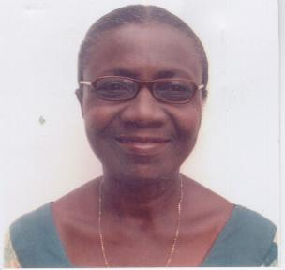

CURRICULUM VITAE

NAME : Christine Opokua Kisiedu (Nee AGYEI)

NATIONALITY : Ghanaian

DATE OF BIRTH : 7th March 1937

PRESENT POSITION AND : Associate Professor (on Contract)
ADDRESS Office Department of Information Studies, University of Ghana
P. O. Box LG 60, Legon, Ghana

Private : P. O. Box LG 397, Legon, Ghana

Tel. : (233-24) 4373173

E-mail : ckistiedu@ug.edu.gh
christinekisiedu@yahoo.co.uk

EDUCATIONAL BACKGROUND:

- University Education

M. Lib. College of Librarianship Wales (CLW), (now Department of Information Studies, University College of Wales) Aberystwyth, 1978.

M. A. (Inf. Stds., Soc Sci) Postgraduate School of Librarianship and Information Studies, University of Sheffield (now
Department of Information Studies), 1976.

Dip. Lib. Postgraduate School of Librarianship and Archives, (now School of Library, Archive and Information Studies), University College London, 1966.

B.A. (Hons) History, Second Class Upper (London) University College of Ghana, Legon, (now University of Ghana), 1962.

- Awards
Nancy Stirling Lambert Scholar for 1976/1977 at the College of Librarianship Wales, Aberystwyth, to conduct research on a Special Classification for Africana. Award given by Messrs. Blackwell. Oxford Booksellers, resulting from an open competition to senior librarians of Anglophone West Africa, in February 1975.

British Council scholar on the M.A. Information Studies Programme, University of Sheffield 1975-1976

Inter University Council (IUC) Award for a study – tour of select British University Libraries and related institutions. September – December, 1973

WORK BACKGROUND

I. BALME LIBRARY, UNIVERSITY OF GHANA, LEGON

1964 – 72 – Cataloguer/Head Cataloguer.

1967/68: 1972/73; 1993/94

- Part-time Lecturer, Department of Library and Archival Studies, University of Ghana

1968 – 70 - Co-ordinator, Social Sciences Section, National Union Catalogue Project,

1993 – 97 - University Librarian and Head of the University of Ghana Library System.

In this capacity, I coordinated a number of innovative projects, including

- A CD ROM Project (supported by AAAS) to improve access to journal literature and other research data

- The first national e-mail Project (based on the store & forward Fidonet system), with the Balme library as the national host;

- 1996 – 1997 – A DANIDA – funded IFLA project on Inter Library Lending & Document Delivery (ILL/DD) in university and research libraries in Ghana.

- 1996 – 1997 Ghana Info Dev project. This is a UNESCO – coordinated Project that is currently being funded by the World Bank’s Info Dev Programme. The project is being implemented by the Ghana National Committee on Internet Connectivity (GNCIC), which I have chaired to date. Project objective: to promote the use of telematics in the public sector of Ghana for development. It is currently sited at the Department of Information Studies.

- DEPARTMENT OF INFORMATION STUDIES (PREVIOUSLY DEPT. OF LIBRARY AND ARCHIVAL STUDIES)

1973 – 80 - Lecturer/Senior Lecturer
Subjects taught: Cataloguing & Classification; Information Science

1989 – 1993 – Senior Lecturer/Head of Department
Subjects taught; graduate level courses, including Cataloguing and Classification; Information Science and Information Retrieval, Marketing in Libraries and Collection Development.

1997 to date – Associate Professor on Post Retirement Contract.
Have been teaching mainly graduate level and some Level 400 courses and supervising Level 400 Long Essays, and graduate theses/dissertations.

III. UNITED NATIONS INSTITUTE FOR NAMIBIA (UNIN), LUSAKA, ZAMBIA (1980 – 1987)
I set up and headed the Information and Documentation Division at the now defunct United Nationals Institute for Namibia, Lusaka, Zambia.

The Division provided information resources on Southern Africa in general and Namibia in particular, for the training of Namibians for independence, and for research on the Namibian Independence Struggle and all aspects of Namibian culture.

IV. STUDY MISSIONS/VISITS TO LIBRARIES AND INFORMATION CENTRES
- The United Kingdom (Nov-Dec. 1973): On attachment at Exeter, Reading and Birmingham University Libraries for administrative experience. Spent a month in each institution. During the period, I also was on a brief attachment at the School of Librarianship, Archive and information Studies, University College London, and the College of Librarianship Wales (CLW), Aberystwyth, Wales.

- Continental Europe (Oct – Nov. 1982): Visited the libraries, archives and related institutions of five (5) countries with historical links to Namibia, to assess the volume of documents/indexes on that country, with a view to their future repatriation or otherwise copying, after Independence.

- Ethiopia (March, 1990): On two weeks’ study visit to ECA/PADIS, Addis Ababa, for a workshop on PADIS methodologies (automated procedures, using the UNESCO CDS/ISIS software).

- The US (March/April, 1994): Undertook five weeks’ coast – to – coast study tour of a number of university libraries in the US, to observe their automated library systems and the management of automated environments.

- South Africa, 13 – 27 July 1997; Led a team of three Ghanaian senior librarians on a study tour of two emerging South African library networks to observe the management of library consortia.

Professional Service
- 1969-1971, 1991-1994 Served as a member of the Council for the Ghana Library Association
(GLA)
- 1989-1991: Chair, Committee on National Information Policy of the GLA.
- 1991-1994: Vice-President of the GLA
- 1992-1996: Served on the Cataloguing Indexing and Abstracting Committee of the Ghana National Scientific and Technological Network (GHASTINET). The Committee designed a technical manual for automated cataloguing in the libraries network members.
- 1999-2001- Interim President, West African Library Association (WALA)
- Feb-JUL 1998- Member Planning Committee of the Conference o National Communication Policy, Was also a member of the Committee that drafted the policy document.
- Feb 1998-Sept 2002 Library Advisor and a member, the Presbyterian University Implementation Committee (PLUIC)
- Mar 1997-2000 Vice Chair and member of ATAC/AISI (the African Technical Advisory Committee of the African Information Society Initiative
- Sept-Nov 2000 Member, Special group set up by the Minister of Education and Sports to design a policy document for setting up a National policy on Distance Education
- 2001 set up the Library of the Catholic University, Fiapre, Sunyani.

The current contact details are published on the Webworld site of the Communication and Information Sector (http://www.unesco.org/webworld/ifap/committees).

