Academic Libraries as Facilitators of digital scholarship: Defining and Designing Online Research Support.
Dr. Maria Carme Torras
Chair, IFLA Information Literacy Section
Library director, Bergen University College, Norway.
mctc@hib.no

Keywords
Academic libraries, media and information literacy, scholarly communication, digital scholarship, digital age, library services, research support, PhD candidates.

- Introduction
This paper addresses how academic libraries can face up to the challenges posed by the digital age and how they can add value to digital scholarship. More specifically, this paper focuses on how the academic library can make a difference to one specific group, namely PhD candidates, thus enhancing the library’s legitimacy as a partner in education and scholarly activity.
This paper is organised as follows. In order to set the scene, some of the changes and challenges that the digital transition has brought about are discussed. Secondly, the findings of a study of PhD candidates’ information needs and practices are presented (Gullbekk, Rullestad and Torras eds., 2013). The study is based on a literature review and a series of focus group interviews of PhD candidates and supervisors in Norway and Denmark. The study was conducted as an attempt to gain a better understanding of PhD candidates’ research and information practices in order to develop relevant online research support for this group. Subsequently, the open educational resource (OER) PhD on Track (http://www.phdontrack.net/ ) is presented. Underpinned by the findings of the study mentioned above, this OER aims at supporting PhD candidates in the scholarly communication process by focusing on the following thematic areas: reviewing and discovering scholarly information, sharing and publishing it, and evaluating and ranking it. These thematic areas address specific issues in which PhD candidates have revealed a need for support. Examples of such issues are gaining an overview of the body of literature to write a literature review, copyright, collaborative authorship and Open Access publishing. Finally, the main ideas presented here are summed up and discussed in the broader context of redefining library research support services in the digital space.

- The digital transition: Changes and challenges
The Internet has brought about significant changes in the way researchers discover, access, read, produce and disseminate scholarly information. Changes in researcher information behaviour and in the publishing world are in turn calling for a major transformation of the role and tasks of the academic library. The academic library cannot succeed in being a relevant and efficient partner in core scholarly activities unless it aims at services that add value to digital scholarship and address the needs of specific groups. E-books, e-journals, mobile platforms and social media (see for instance Weller 2011) have changed and are still transforming scholars’ everyday life. Researchers are no longer to be found at the physical library. As a result, provision of library services and outreach must happen beyond library walls, that is, “on the go and in the [digital] social space” (Nicholas, 2012). It is thus necessary for academic libraries to strengthen their digital presence.
Weller (2011) discusses how technology has transformed scholarly practice. In short, he characterises scholarship as being digital, networked and open. He defines the digital scholar as “someone who employs digital, networked and open approaches to demonstrate specialism in a field” (p.4). He further notes that as a result of the democratisation of the online space, a digital scholar does not longer need to be a recognised academic affiliated to an institution. A digital scholar is also defined by his or her online identity and network. In addition to the Internet, Weller singles out the advent of social networks as having a significant impact on scholarly practice. Online social networks make it possible for researchers to build up peer networks through the use of free or inexpensive user-friendly technology, no longer being dependent on face-to-face interaction. He further singles out openness as having an impact on scholarly practice in the digital age. By openness Weller means both open technology (e.g. open source software, open standards) and “the practice of sharing content as a default” (p.7). Knowledge dissemination is no longer restricted to costly print journals. Ideas can flow and be shared instantly through a variety of free or inexpensive tools. In addition, readership is greatly increased when access to content is open.
The digital transition has led to disintermediation and decoupling of academic libraries from scholarly information communication and provision (Rowlands et al., 2008; Rowlands et al., 2011; Nicholas et al., 2011). Academic libraries struggle with weak and little visible presence in the existing digital scholarly space and are not good enough at promoting their resources there (Rowlands and Nicholas, 2006; Nicholas et al., 2011). Academic libraries are no longer the main gatekeepers and providers of quality scholarly information. In the overflow of digital information that surrounds scholars, Google Scholar and Google Books are examples of shortcuts to discover and access the scholarly information they need, thus bypassing the library. Incompleteness of library digital collections, which is only partly due to financial hardship and ill-suited acquisition business models, also weakens the perceived value of the library.
As compared to other key stakeholders at the mother institution, the library in general lacks academic capital (Whitworth, 2012), which calls into question its legitimacy as a partner in education and research. Media and information literacy has become a clear strategic development area at many academic libraries. This area, when explored in the context of research support and digital scholarship, lends academic libraries an excellent opportunity to prove their relevance and articulate its active participation in the mother institution’s core activities. Media and information literacy encompass competencies, knowledge and behaviour which are essential to the discovery, access, production and dissemination of scholarly activity. Academic libraries have embraced the role of media and information literacy educators by bringing together information expertise and educational and research competencies, the latter enhanced through professional development and new recruitment.
Increasing the library’s academic capital requires a definition of its role in digital scholarship. In turn, this role definition requires a deep understanding of the digital scholar’s information practices, preferences and needs. Such an understanding is essential to the design of effective and relevant support services which add value to digital scholarship, thus increasing the library’s academic capital.
Digital scholars are however a heterogeneous group. There are obvious differences between the information needs and behaviour of a senior professor and a new PhD candidate. For this reason, the library cannot aim at “one size fits all” research support services. Services must be sensitive to the stage at which scholars find themselves in their career. In this sense, PhD candidates can be regarded as a distinct group of novice digital scholars to whom library services should make a difference. In the next section, the information needs and practices of this group are briefly presented.

3. PhD candidates’ information needs and practices
Gullbekk, Rullestad and Torras (eds.) (2013) report on the findings of a study of PhD candidates’ information needs and practices. The study was conducted as an attempt to gain a better understanding of PhD candidates’ research and information practices with the ultimate aim of developing relevant library research support in the digital space for this group. The study is based on both a scoping literature review, consisting of 55 unique references, and a series of focus group interviews of PhD candidates and supervisors. A total number of 21 PhD candidates and 15 supervisors were interviewed in Norway and Denmark. The study reveals a number of library research support areas related to reviewing and discovering scholarly information, publishing and disseminating it, as well as evaluating and ranking it. In what follows, the main findings of the focus group interviews are presented. The main findings are confirmed by the main findings of the literature review. The reader is referred to Attinger et al. (2013) for more detailed findings of the literature review which was conducted in the study.
In terms of discovering scholarly information, the interviewed PhD candidates stress the need to be efficient in their research work given the scarcity of time they experience. Information discovery is time consuming and the candidates’ focus on time saving leads to a preference for easily available online literature. While they seem to be confident as to how to get hold of specific references, they do express concerns in terms of knowing how to gain a good overview of the literature in their research field. Gaining such an overview is regarded as a core activity in their research work, for example when writing their thesis literature review. They express uncertainty about being able to discover all the relevant literature and to keep completely updated in their field. They acknowledge that better searching skills and better familiarity with relevant information resources would result in more effective work.
As regards publishing scholarly information, whether as part of a formal requirement or a strategy to promote their academic profile, PhD candidates report challenges when engaging in collaborative authorship. They also experience difficulties in trying to understand the complexities of copyright. Supervisors in the focus group interviews express concerns about academic integrity on account of the PhD candidate diversity they encounter. Being novice researchers with very different academic and cultural backgrounds, PhD candidates may have different perceptions, knowledge, skills and attitudes in the way they use and refer to other researchers’ work in their own research production. Further, the study reveals that PhD candidates’ knowledge about open access publishing seems to be limited and to a certain extent inaccurate. Candidates point out the advantages of fast publishing in Open Access journals as compared to slow publishing processes in more traditional journals. However, candidates raise concerns about the quality of Open Access journal publications and peer reviewing in these journals.
In terms of evaluating and ranking scholarly information, the focus group interviews reveal that impact factor is regarded as a quality indicator. It does not play a major role in the candidates’ selection of publishing channel or literature to read. Nevertheless, there are clear discipline differences. Impact factor is more relevant to candidates in the natural sciences and medicine than to those in the social sciences and the humanities.
When asked about the library services PhD candidates need, they single out information discovery, copyright, reference management systems and research information systems as relevant research support areas. In their opinion, library research support in the digital space should focus on showcasing the complexity of information searching and management processes. Candidates ask for discipline-specific tailoring of services as well as services supporting multidisciplinary research. Further, candidates stress the value of networking with peers and other resource people like library staff. Digital research support should focus on facilitating online communities and contact between candidates and between candidates and other resource people. In this respect, some studies in the literature review (Attinger et al. 2013) report that candidates increasingly value the role of library staff as they turn to them for help over time. Finally, candidates urge the library to promote research support services better. Many are not aware of existing services or do not manage to see their relevance because of poor communication.
The study presented here provides a knowledge base on which online research support for PhD candidates can be designed, both in terms of content and functionality. In the next section, the OER PhD on Track is presented as an example of online research support developed on the basis of the findings presented in this section.

- PhD on Track: Supporting digital scholarship from its early stages
PhD on Track (http://www.phdontrack.net/ ) is the product of the Scandinavian collaborative project Information Management for Knowledge Creation (http://inma.b.uib.no/). The project was funded by the National Library of Norway. PhD on Track has been developed on the basis of the study presented in Section 3. The aim of this OER is to empower PhD candidates at the early stages of their career by enhancing their media and information literacy in the context of scholarly communication. It is a contribution to the overall PhD programme training in transferable skills.
An attempt has been made to design the support offered by PhD on Track in line with Weller’s (2011) definition of scholarship as digital, networked and open. PhD on Track is an open educational resource licensed under Creative Commons (CC BY-NC-SA). It has been designed on an open source publishing platform, namely WordPress. The resource has been produced in English. Although this is a Scandinavian resource, English was chosen in order to reach out to an increasingly international target group in Scandinavian Higher Education.

Content which cannot be accessed on mobile devices is not digitally visible. Tablets, smart phones and other digital devices have become part and parcel of the digital scholar’s daily life. For this reason, PhD on Track is design-responsive.

An important aspect in the actual production of this resource has been user involvement to ensure relevance to the target group both in terms of content, design and functionality. In addition to the focus group interviews mentioned in Section 3, usability tests and a focus group interview were carried out at different stages of the production process, for instance when wireframes were produced. The design and functionality choices made aim at supporting the main objectives of PhD on Track: illustrating challenges in the scholarly communication process, explaining processes, demonstrating techniques and strategies, and encouraging reflection and critical perspectives on scholarly practices (Gullbekk, Rullestad and Torras, 2013).

As Figure 1 below shows, PhD on Track is divided up into three modules: reviewing and discovering scholarly information, sharing and publishing it, and evaluating and ranking it.

Figure 1. Homepage of the open educational resource PhD on Track (http://www.phdontrack.net/ ).

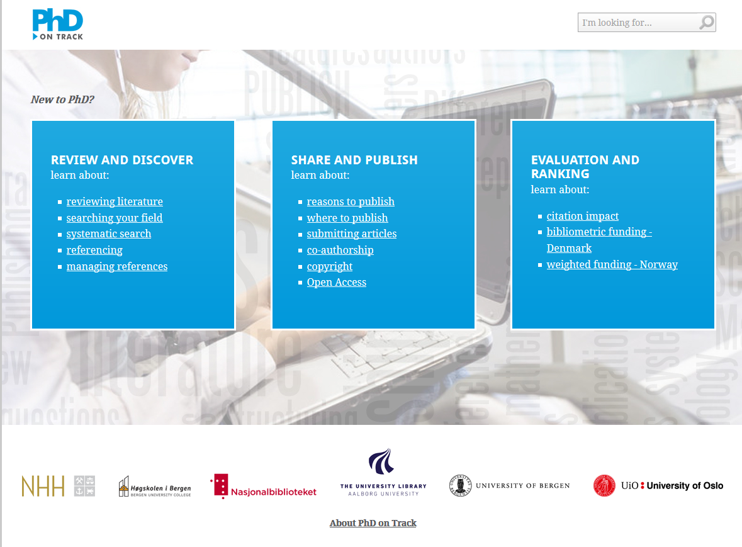

The module Review and Discover focuses on discovery techniques, methods and tools to map the literature in the field, as well as referencing and the use of referencing management systems. The module aims at improving the efficiency and quality of the candidate’s workflow. The module Share and Publish helps the PhD candidate to make informed decisions about where and how to publish so as to increase the chances of publishing and disseminating her or his scholarly work. Article submission and peer-reviewing processes as well as copyright issues are explained. Online venues for peer networking and principles of collaborative authorship are discussed. Further, open access publishing is presented. As a publishing scholar, the candidate must be aware of how funding bodies rank publications. In the module Evaluation and Ranking, the PhD candidate learns about how research is evaluated for funding purposes. The module focuses on how research impact is measured by citation frequencies and how publishing activities are ranked through bibliometric and weighted funded models.
In the preliminary evaluations conducted in the production process (Gasparini and Cutler, 2013), PhD candidates describe PhD on Track as a relevant resource for new PhD candidates in terms of the choice of thematic areas. They are also positive to the design and navigation. They especially like that all information is available on one single site as this helps them meet their information needs in a more efficient way (see the discussion of efficiency in the research process in Section 3).

- Concluding remarks: Redefining library research support in the digital space
This paper has addressed some of the challenges that PhD candidates, as novice digital scholars, and academic libraries face up to in the digital transition. By adopting an evidence-based approach to developing online research support for this specific group of scholars, the library can contribute to both increasing its digital presence and academic capital in Higher Education, as well as helping PhD candidates enhance their own digital presence as scholars. The OER PhD on Track has been presented as an example of online research support which addresses specific information challenges experienced by PhD candidates in their scholarly activity, as revealed by the study presented here.
PhD on Track was launched in May 2013 and has been conceived as a dynamic OER. There are plans to pursue further evidence-based work in order to develop it and ensure its quality and relevance in the future. The first task ahead is to ensure good dissemination of this OER and implementation and evaluation in actual PhD programmes. In the further development of this resource, at least two issues need to be addressed. The first one concerns further enhancing PhD candidates’ digital presence by facilitating online networking which includes both peers and other stakeholders such as information specialists. The second issue concerns language diversity in the digital space. Because of financial and time constraints amongst other reasons, PhD on Track was developed in English only, even though it was produced in a Scandinavian context. A contribution to language diversity in the digital space should be made here by making the OER available in other languages, Norwegian or Danish being the most obvious choices.
In the digital age, the academic library’s added value lies in offering support beyond the traditional areas of literature discovery and provision and venturing into other areas of scholarly activity such as publishing and disseminating scholarly production, as well as increasing its impact and readership for instance through the use of social media. Further, the academic library’s value lies in its ability to meet digital scholars in their natural habitat, be it their desktop or the mobile device of their choice. Venturing into these less traditional research support areas raises concerns as to to what extent academic libraries have the necessary digital and technological competencies to fully seize the opportunities that the digital space offers and to meet the needs of the digital scholar. Professional development, learning at the workplace and new recruitment at academic libraries need to be better understood in the context of the digital transition to ensure that academic libraries have the academic capital they should have in the years to come.

References
Attinger, G. et al. 2013. Literature Review. In Gullbekk, E., Rullestad, T. and Torras, M.C. (eds.) 2013. PhD candidates and the research process. The library’s contribution. Skrifter fra Universitetsbiblioteket i Oslo, 8, pp. 15-50. Oslo, University of Oslo. Available from http://www.ub.uio.no/om/skrifter/hefte08.pdf .
Gasparini, A. and Cutler, I. 2013. PhD on Track – testmetodikk når målgruppen involveres. Presentation at the conference PhD on Track. En konferanse om bibliotekenes veiledning av Ph.d. kandidater. Gardermoen, Oslo, 23 May 2013. Available from http://inma.b.uib.no/seminar/ .
Gullbekk, E., Rullestad, T. and Torras, M.C. 2013. PhD on Track – Lansering av de nettbaserte læringsmodulene i PhD on Track. Presentation at the conference PhD on Track.
En konferanse om bibliotekenes veiledning av Ph.d. kandidater. Gardermoen, Oslo, 23 May 2013. Available from http://inma.b.uib.no/seminar/ .
Gullbekk, E., Rullestad, T. and Torras, M.C. (eds.) 2013. PhD candidates and the research process.
The library’s contribution. Skrifter fra Universitetsbiblioteket i Oslo, 8. Oslo, University of Oslo. Available from http://www.ub.uio.no/om/skrifter/hefte08.pdf .
Nicholas, D. 2012. Desintermediated, Decoupled and Down. CILIP Update, April 202, pp. 29-31.
Nicholas, D., Watkinson, A., Rowlands I. and Jubb, M. 2011. Social Media , Academic Research and the Role of Academic Libraries. The Journal of Academic Librarianship, 37, 5, pp. 373-375.
Rowlands, I., Nicholas D., Russell B., Canty, N. and Watkinson, A. 2011. Social Media Use in the Research Workflow. Learned Publishing 24, 3, pp. 183-195.
Rowlands, I. et al. 2008. The Google Generation: The Information Behaviour of the Researcher of the Future. Aslib Proceedings: New Information Perspectives, 60, 4, pp.290-310.
Rowlands I. and Nicholas D. 2006. The Changing Scholarly Communication Landscape: An International Survey of Senior Researchers. Learned Publishing, 19, pp. 31-55.
Weller, M. 2011. The Digital Scholar. How Technology is Transforming Scholarly Practice. London, Bloomsbury Academic.
Whitworth, A. 2012. The Reflective Information Literacy Educator. Nordic Journal of Information Literacy in Higher Education, 4, 1, pp.38-55. Available from https://noril.uib.no/index.php/noril/article/view/151/11 .

PhD on Track has been developed jointly by the libraries at Bergen University College, the Norwegian School of Economics, the University of Bergen, the University of Oslo and the University of Aalborg.

