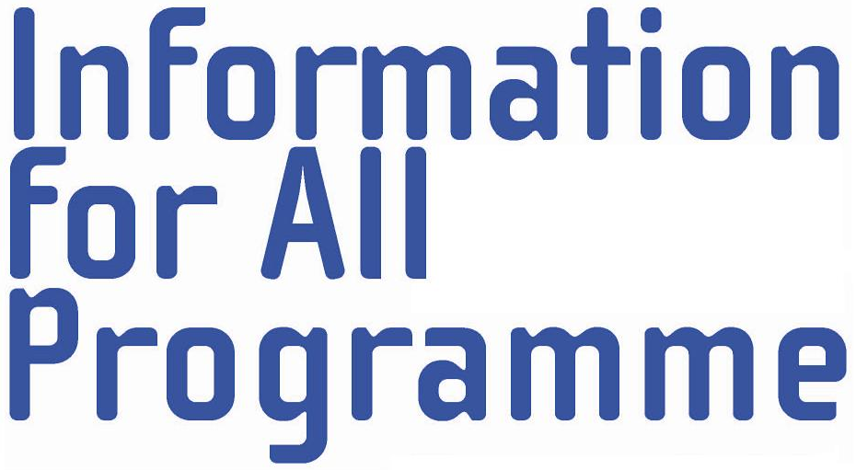

Message from Dr Karol Jakubowicz,
Chairperson, Intergovernmental Council, Information for All Programme,
to the participants in the International Conference
“Linguistic and Cultural Diversity in Cyberspace”
Yakutsk, Russian Federation, 2-4 July 2008

According to a recent forecast, the total number of people online will climb to 1.8 billion by 2012. So, within the next four years, one quarter of the world's population will be connected to the internet. Russia will be among the countries showing the highest growth rate, alongside China, India and Brazil.
It is therefore fitting that the Russian National IFAP Committee is one of the strongest and most active ones in the IFAP family. Given the diversity of cultures and languages among the peoples of the Russian Federation, it is also very appropriate that it hosts the conference on “Linguistic and Cultural Diversity in Cyberspace”.
2008 has been proclaimed by the United Nations the International Year of Languages. “The first instrument of a people’s genius is its language,” said the French writer Stendhal, so it was most appropriate that the Year was launched by UNESCO on 21 February, International Mother Language Day. However, the whole point about linguistic and cultural diversity is that we should respect every language and culture and use genuine multilingualism to promote unity in diversity and international understanding, as well as communication with the peoples of the world.
The Information for All Programme (IFAP) was established by UNESCO to provide a framework for international co-operation and partnerships in “building an information society for all”. IFAP’s focus is on ensuring that all people have access to information they can use to enhance their lives. It is crucially important that information should be available in different languages, also in cyberspace, so that all individuals, peoples and nations can rely on sources of information in their own languages.
IFAP is now preparing to develop templates of national information policy frameworks. These templates will certainly need to highlight the need for policy to ensure access to information in different languages, and to develop and safeguard linguistic and cultural diversity. This will be further developed in contributions to those templates provided by working groups, including those dealing with information accessibility and information ethics. We hope that Russian experts will join those groups and that we will be able to draw in this work on the results of the Yakutsk conference. We would also welcome other forms of contribution by the Russian National IFAP Committee, as well as by Russian experts, to the work of IFAP.
As one of the experts who contributed to the drafting of the 2003 UNESCO Recommendation concerning the Promotion of Multilingualism and Universal Access to Cyberspace, enshrining precisely the values and ideas to which the Yakutsk conference will be devoted, it is my privilege to wish participants in this high-level conference – on behalf of the IFAP Council and Bureau – successful and fruitful debates. We look forward to the results of the conference and hope to learn from them.

